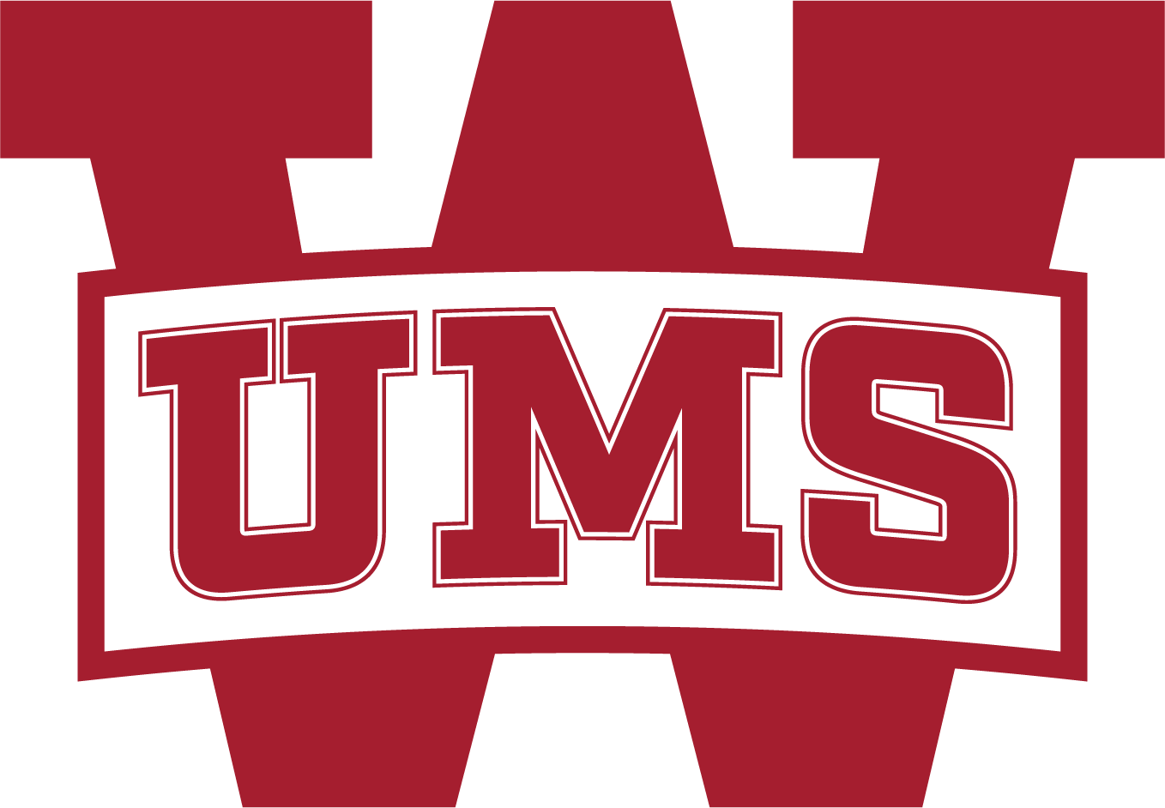
Dear UMS- Wright Family,
Welcome to the 2022-2023 school year. I look forward to seeing you all on campus this year. The Parents’ Association (PA) is a great way to get involved and engage in your child’s school and education. The mission of our association is to support the students, teachers, and faculty of UMS -Wright through Mind, Body, and Spirit.
As a parent, you are already a member of the Parents’ Association. There are no membership fees. Our entire group is run entirely by volunteers. We encourage you to volunteer in any way you can share your time and talents. The Parent’s Association offers a wide variety of volunteer opportunities throughout the year. The variety of volunteer opportunities allows you to engage as little or as much as you like. Please ﬁll out the (HYPERLINK TO QR CODE) survey and indicate how you would like to get involved.
The Parents’ Association organizes Teacher Appreciation week, hosts all receptions after student performances and awards ceremonies, Homecoming activities, works on beautiﬁcation around our campus, and organizes parties/events at each grade level.
To support our school, the Parents’ Association hosts four fundraisers each year – Bidding for the Bulldogs: an online auction & parent party, Homecoming - online spirit store, Dawgs on the Hunt, and Used Uniform sales. Our fundraising eﬀorts yield around $100,000 annually. Funds raised through these fundraisers are used to purchase large “Wish List” items that are not covered by tuition or the Wright Fund. These items are used to enhance our students’ and teachers’ everyday life on campus. Items purchased from the PA fundraising eﬀorts have included: funding for non-revenue sports, curriculum enhancements, Fine Art needs, continuing education for our faculty and staff, technology enhancements across campus, and much more.
The Parents’ Association truly appreciates each and every volunteer who has dedicated his/her time to creating a better school for our children. It is my hope that you join us and ENGAGE in your child’s time at UMS-Wright. I, along with the entire Parents’ Association Executive Committee, welcome you and look forward to seeing you around campus and at Parents’ Association events.
Best-
Brandi T. Purvis
’22-’23 UMS-W Parents’ Association President
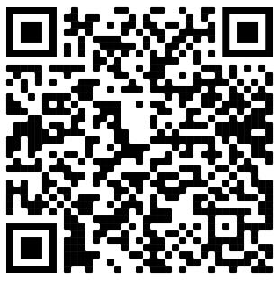
QR code for Volunteer Sign-up

